Al-Aqsa University  Faculty of Engineering  Intelligence Systems & Computer Engineering Dept. |  | جامعة الأقصى  كلية الهندسة  قسم هندسة النظم الذكية و الحاسوب

Smartphones Programming (ENGS4301)

Lab 1: Introduction to Dart

Presented to: Eng. Mohammed Iyad Al-Laham

Student name: Samar M. Balousha
Student number: 2320222601

Semester: Second Semester 2025/2026

Question 1: Write a Dart program that prints information:
- Code
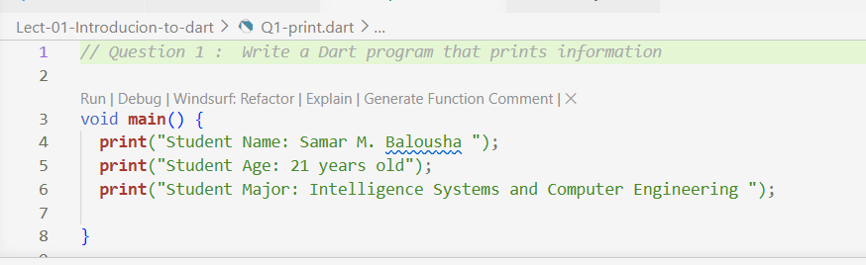
- Result
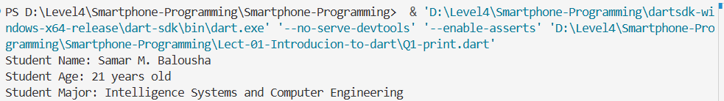

Question 2: Arithmetic operations (sum, subtract, multiply, division, reminder)
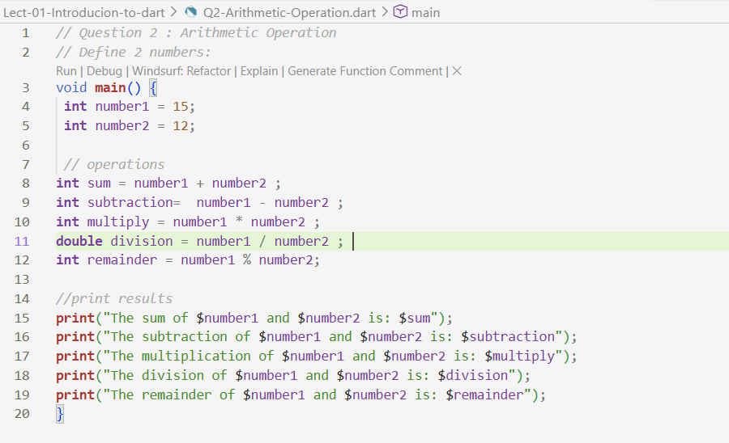
- Code

- Result
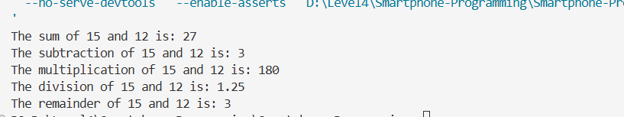

Question 3: Evaluating Complex Expressions
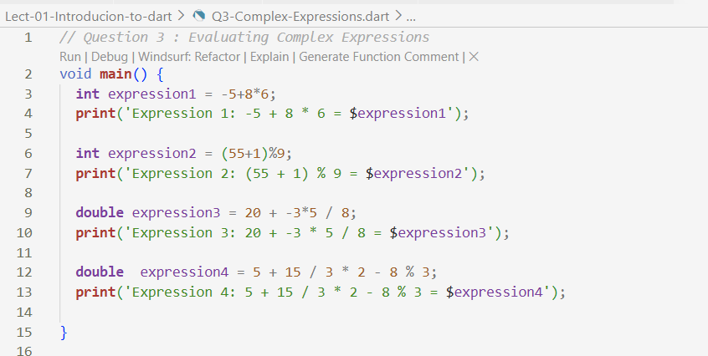
- Code

- Result
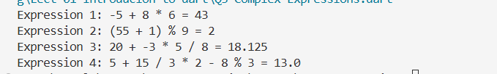

Question 4: Print information
- Code
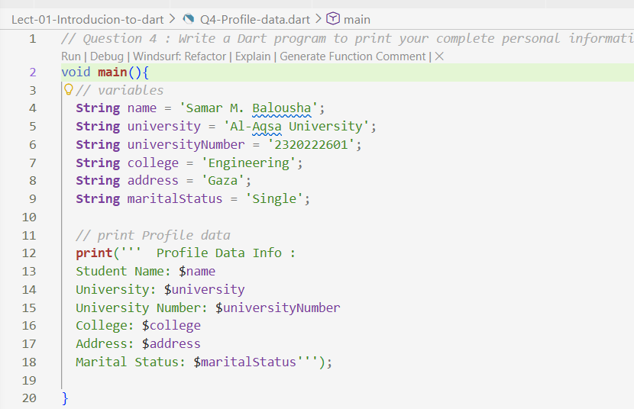
- Result
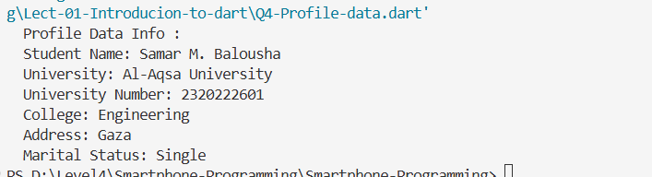

Question 5: Draw a shape
- Code
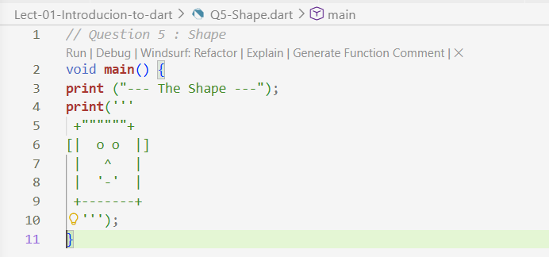
- Result
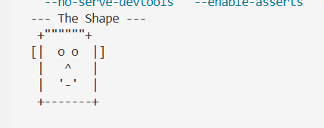

Question 6: Area of rectangle
- Code
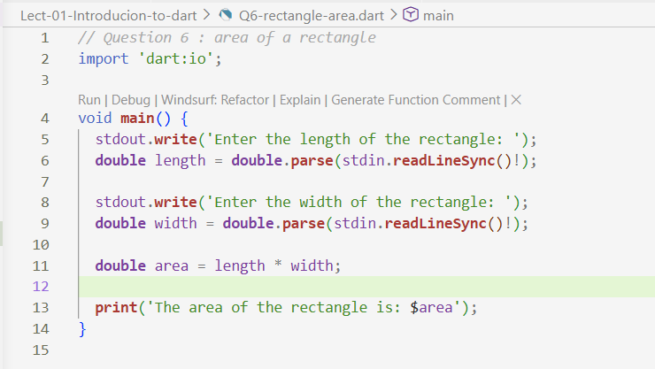

- Result
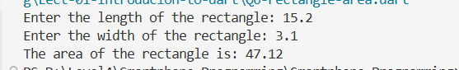

Question 7: Area of a circle
- Code
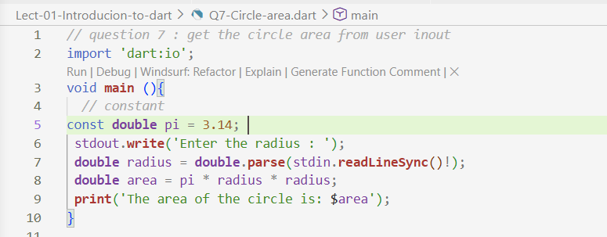

- Result
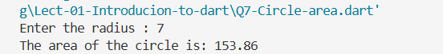

Question 8: Shekel to Dollar
- Code
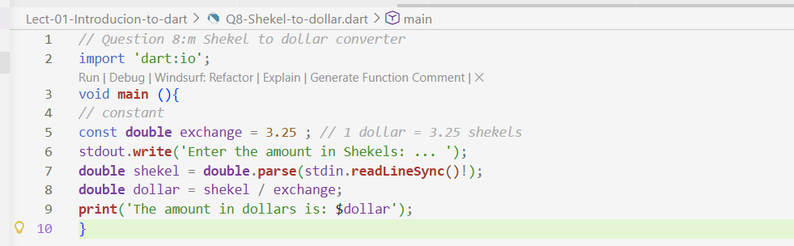

- Result
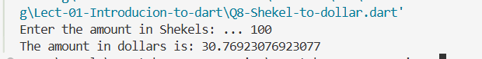

Question 9: Temperature Converter
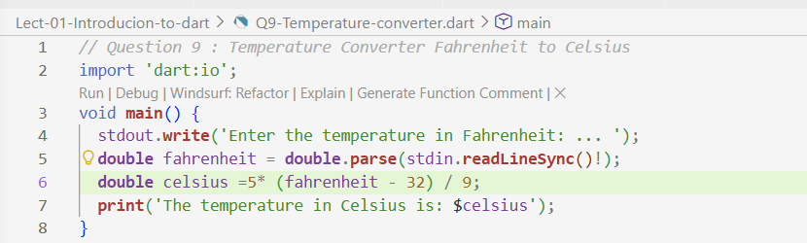
- Code

- Result

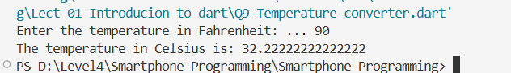

Question 10: Length Converter
- Code
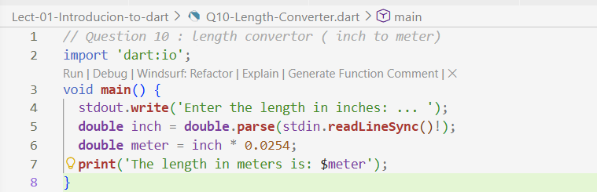
- Result
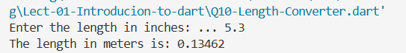

Question 11: Summing Digits of a Number
- Code
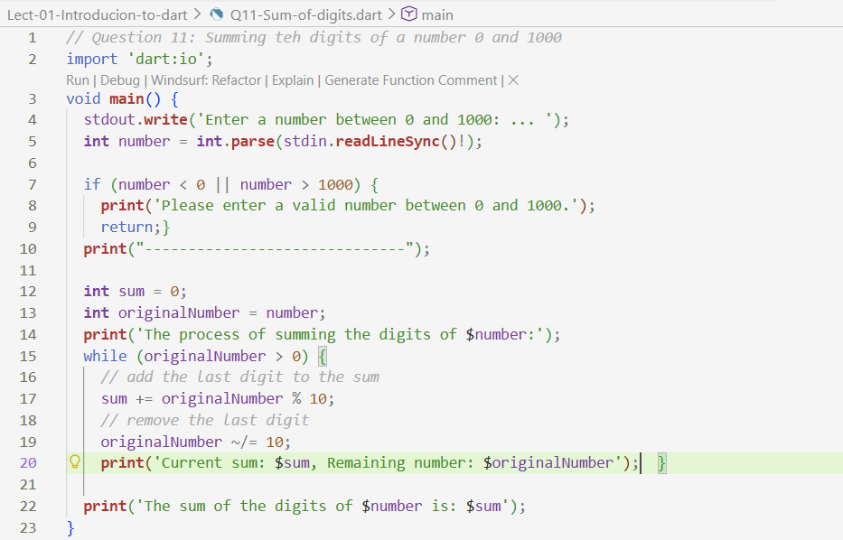
- Result
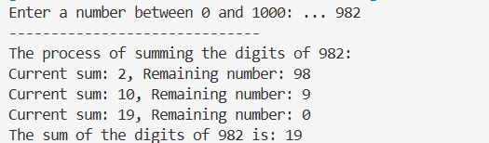

Question 12: Time Converter
- Code
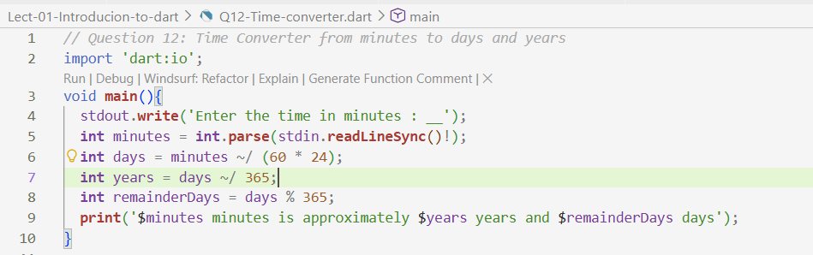
- Result
